18.45: From Table (18.2), the speed is (1.60)v s, and so
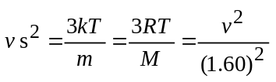
(see Exercise 18.48), and so the temperature is

